Interview preparation
In Terraform, modules are the primary way to package and reuse your AWS infrastructure code. Instead of writing a thousand lines of code in one file, you create small, specialized "containers" for specific services, like IAM policy creation, ECS cluster, S3 bucket, VPC creation, WAF rules.
Module folder contains
- main.tf: Contains the actual resource "aws_..." blocks.
- variables.tf: Defines the inputs (e.g., vpc_cidr, instance_type).
- outputs.tf: Exports data for other modules (e.g., vpc_id, subnet_ids).
- README.md: Explains how to use the module.
Reusability: Build a "Golden VPC" module once and use it across 50 different projects.
Consistency: Ensure every S3 bucket created in your company has encryption and versioning enabled by default.
Separation of Concerns: One team can manage the "Networking" module while another manages the "Application" module.

module "my_vpc" {
source = "./modules/aws-vpc" # Local path or Git URL
region = "us-east-1"
vpc_cidr = "10.0.0.0/16"
}
module "web_server" {
source = "./modules/aws-ec2"
instance_type = "t3.micro"
vpc_id = module.my_vpc.vpc_id # Passing an output from one module to another
}
Terragrunt is a "thin wrapper" that sits on top of Terraform or OpenTofu to help you manage complex configurations across many environments.
• Managing Multiple Environments: If you have 10+ environments (Dev, Staging, Prod across multiple regions), Terragrunt prevents you from copy-pasting your backend and provider blocks.
• Keeping Code DRY (Don’t repeat yourself): Use it when you want to define your modules once and inherit configurations in a parent-child structure.
• Dependency Management: When one module (like a VPC) must be finished before another (like an EC2) can start, Terragrunt manages the order and passes outputs between them.
• Automatic State Management: It automatically creates your S3 buckets and DynamoDB lock tables if they don't exist

To implement secret detection in a Jenkins pipeline, you typically use a tool like Gitleaks or TruffleHog. These are specifically designed for CI/CD environments where you want the build to fail if a secret is committed.
• Local (Pre-commit): Blocks the developer from committing secrets locally.
• Jenkins (The Gate) – git leaks: Scans the code during the build to catch anything that bypassed the local hook.
Install Gitleaks on your Jenkins Agent
The Jenkins Pipeline Stage
Implementing Local Pre-commit Hooks

How to scale Jenkins
To scale Jenkins beyond a single server, you use a Controller-Agent (Master-Slave) Architecture. This prevents the main Jenkins server from slowing down by offloading the actual "work" (building, testing, and deploying) to separate worker machines.
• The Controller (Master): Handles the UI, configuration, scheduling jobs, and managing the environment. It should not run heavy build jobs.
• The Agents (Nodes): Small machines or containers that perform the actual build steps. You can have hundreds of agents connected to one controller
Methods : Static, Dynamic and scaling with K8S

Stateless - A stateless system does not retain memory of previous requests. Every request is treated as a completely new interaction.
Stateful - A stateful system remembers previous interactions and uses that information in future requests.
Karpenter - is a Kubernetes node autoscaler that automatically provisions and removes worker nodes based on application demand. It was originally created by AWS and is widely used with Amazon EKS
Cilium - is an open-source Kubernetes networking, security, and observability platform that uses eBPF (Extended Berkeley Packet Filter) in the Linux kernel to provide high-performance networking and security for containers and microservices.

Ansible is an open-source IT automation engine used for configuration management, application deployment, and infrastructure orchestration. It allows you to describe your desired server state in simple, human-readable text files.
- Idempotency: One of Ansible's core strengths. If you run a playbook twice, Ansible checks the current state and only makes changes if they are necessary. If the server is already in the "correct" state, Ansible does nothing.
- Playbooks: These are YAML files where you define your automation tasks (e.g., "Install Nginx," "Copy config file," "Restart service").
- Inventory: A simple file (usually ini or yaml) that lists the IP addresses or hostnames of the servers you want to manage.
- Modules: These are the "tools in the toolbox." There are thousands of built-in modules for everything from managing AWS resources (amazon.aws.ec2) to installing packages (apt, yum) or managing users.
Terraform for "Provisioning" (creating the hardware/network) and Ansible for "Configuration Management" (setting up the software inside that hardware).

Ansible step by step
Yaml file (webserver_setup.yml)
---
- name: Configure Apache Web Server
hosts: webservers # Defined in your inventory file
become: yes # Run as sudo/root
vars:
http_port: 80
app_name: "My AWS App"

tasks:
- name: Ensure Apache is at the latest version
ansible.builtin.package:
name: httpd
state: latest

- name: Copy index.html from local files to server
ansible.builtin.template:
src: ./templates/index.j2
dest: /var/www/html/index.html
mode: '0644'
notify: Restart Apache # Only runs if the file changes

- name: Ensure Apache is started and enabled
ansible.builtin.service:
name: httpd
state: started
enabled: yes

handlers:
- name: Restart Apache
ansible.builtin.service:
name: httpd
state: restarted
inventory file extension is .ini (Example inventory.ini)
[webservers]
13.233.x.x ansible_user=ec2-user ansible_ssh_private_key_file=~/key.pem
Command for run playbook
ansible-playbook -i inventory.ini webserver_setup.yml

A playbook is a single YAML file that maps a group of servers to a list of tasks.
- Structure: It contains the hosts, vars, and tasks all in one place.
- Usage: Best for small, one-off tasks or simple automation.
- Downside: As you add more tasks (installing DB, setting up users, configuring SSL), the file becomes massive, hard to read, and impossible to reuse for other projects.
A Role is a structured directory that breaks down a playbook into reusable components. Instead of one long file, you have specific folders for tasks, variables, files, and templates.
- Structure: Follows a strict standard (folders like /tasks, /vars, /templates, /handlers).
- Usage: The gold standard for enterprise production. You create a role once (e.g., a "Security-Hardening" role) and call it in 50 different playbooks.
- Benefit: Cleanliness. Your main playbook might only be 10 lines long because it just calls different roles.

The "IP Exhaustion" Problem: When using Azure CNI, every Pod gets a real IP from the VNet. If you have a /24 subnet and 3 nodes with 30 pods each, you'll run out of IPs quickly. How would you solve this without recreating the VNet? (Hint: Look into Azure CNI Overlay or Dynamic IP Allocation). - Azuer CNI overlay
Private Clusters: If you deploy a Private AKS Cluster, the API server has no public IP. How does your Azure DevOps Hosted Agent (running on the public internet) connect to the cluster to run kubectl apply? – Self hosted agent or Azure bastion/vpn
You used Terraform to deploy an AKS cluster. Someone manually changed the Node Pool count in the Azure Portal. What happens when you run terraform plan? How do you use the lifecycle block in Terraform to prevent the CLI from overwriting those manual "emergency" scales? – Drift & lifecyle – Terraform plan
How do you perform a zero-downtime Kubernetes version upgrade using Terraform? If you just change the version number and apply, does it do a rolling update or recreate the whole cluster?
How do you ensure that your AKS cluster only pulls images from your specific Azure Container Registry (ACR) and blocks everything from Docker Hub? (Hint: Azure Policy for Kubernetes) – Azure built-in policy for K8S
Your AKS cluster is running 24/7, but it's only used during office hours. How would you automate the starting and stopping of the cluster using Azure DevOps to save costs? – Azure DevOps pipeline – cron schedule
Terraform
You inherit a large Terraform state file containing VPC, EKS, and RDS resources for all environments. How do you safely split this into smaller, logical states (e.g., networking, database, apps) without recreating resources? – terraform state rm remove resources from original state and terraform import into split small state files.
What happens if two CI/CD pipelines (e.g., in Jenkins) try to run terraform apply on the same state file simultaneously? How do you prevent this using a remote backend like S3 or Azure Blob Storage? – state locking – use DynamoDB table to your S3 /blob storage
How do you manage provider and module versions across multiple teams to prevent "dependency hell"? What is the role of the .terraform.lock.hcl file in this process? – Lock file (.terraform.lock.hcl) ensures that evenyone on the team uses same versions.
- How do you use Terraform to deploy the same module across multiple AWS accounts or Azure subscriptions within a single configuration. - Use Provider Aliases. Define multiple provider blocks (e.g., one for us-east-1 and one for us-west-2), then pass the specific alias into the module using the providers map.
Jenkins
- How do you trigger a Jenkins pipeline from an AWS S3 event or a CloudWatch Alarm? - I use a Lambda function as a bridge. The S3 event triggers Lambda, which then makes an authenticated API call to the Jenkins Remote Access API to trigger the specific job.
- How do you implement 'Pipeline Gates' for compliance? - I implement a mandatory Quality Gate stage. If SonarQube or Snyk returns a "Fail" status via their API, I use the error signal in Groovy to abort the pipeline immediately.
- How do you handle a pipeline that needs to wait for an external event (like a 2-hour manual security audit) without blocking a Jenkins worker thread? - Use the input step inside a stage. Explain that when an input is triggered, the worker node is released, and the pipeline remains in a "paused" state in the master's memory until approved.
- You have 50+ microservice pipelines deploying to AWS ECS and legacy Oracle DBs. How do you ensure that all teams follow standard security scans (like SonarQube, Gitleaks, Trivy) without manually editing 50 separate Jenkinsfiles? – shared libraries
- Can you describe your experience with AWS services and how they have supported your DevOps initiatives?
How do you approach incident response when an alert indicates a system issue?
A.
AI answer for you
- My approach to incident response begins the moment an alert is raised. Firstly, at LTIMindtree, we set up a structured incident response plan that detailed roles and responsibilities for each team member.
- Once an alert is triggered, I quickly assess the parameters of the alert: Which system is affected? What metrics are concerning? This initial analysis informs the urgency and scope of the response.
- Using tools integrated with our monitoring setup, I gather logs and metrics related to the event. This includes querying CloudWatch and checking logs in the ELK stack for relevant data.
- Following this, coordination with relevant teams—such as development or operations—is critical. I facilitate a quick meeting or use communication channels to keep all stakeholders informed and collaborative.
- After resolving the issue, I conduct a post-mortem analysis to identify the root cause. This scrutiny helps inform preventative measures going forward, whether adjusting alert thresholds, refining processes, or enhancing training.
- Finally, documentation of the incident and the lessons learned is crucial. I maintain records of incidents to reference in future training and reviews, empowering teams to better react to similar situations.
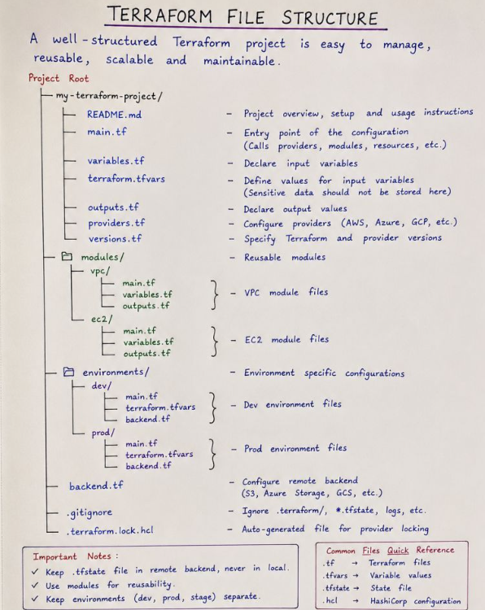
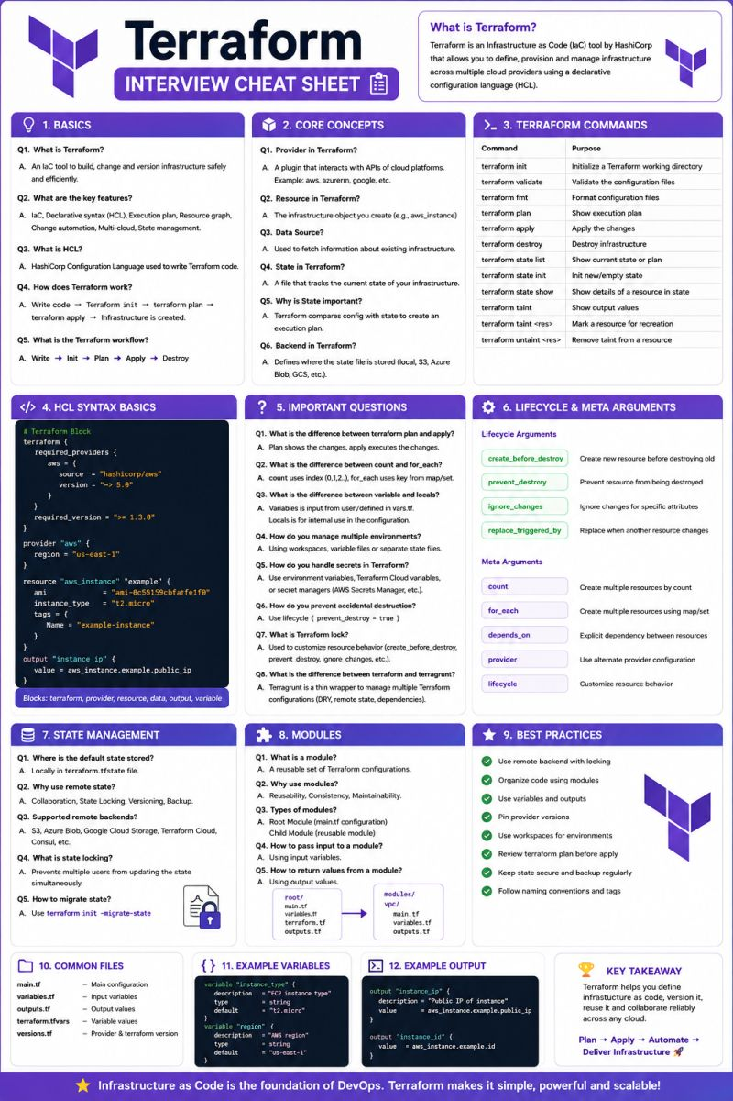
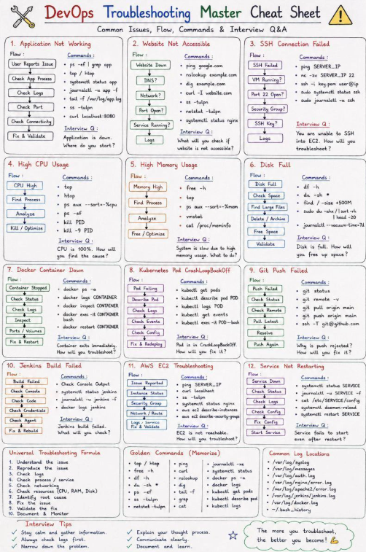
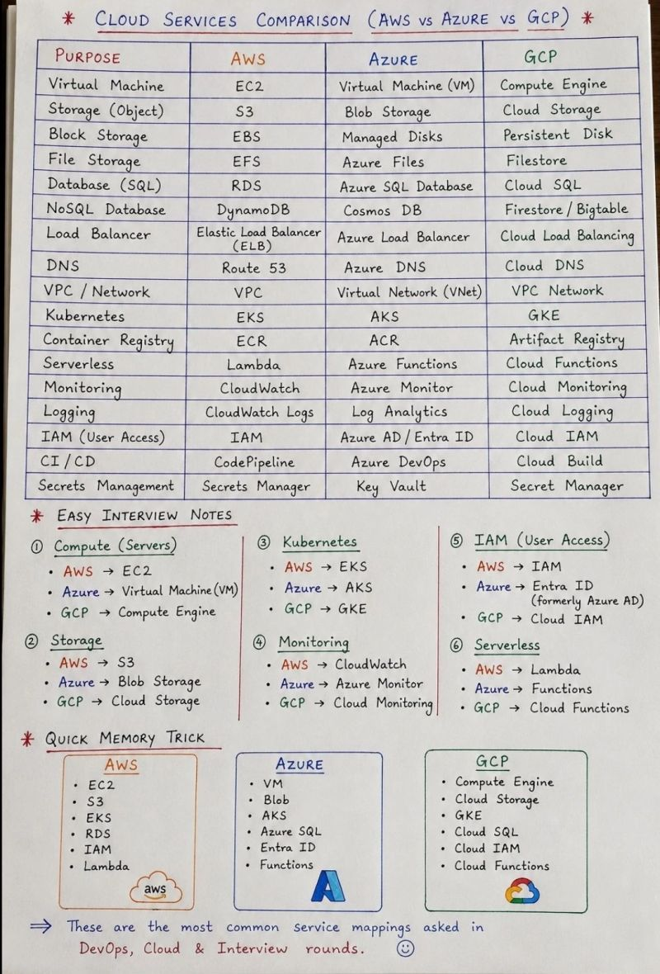
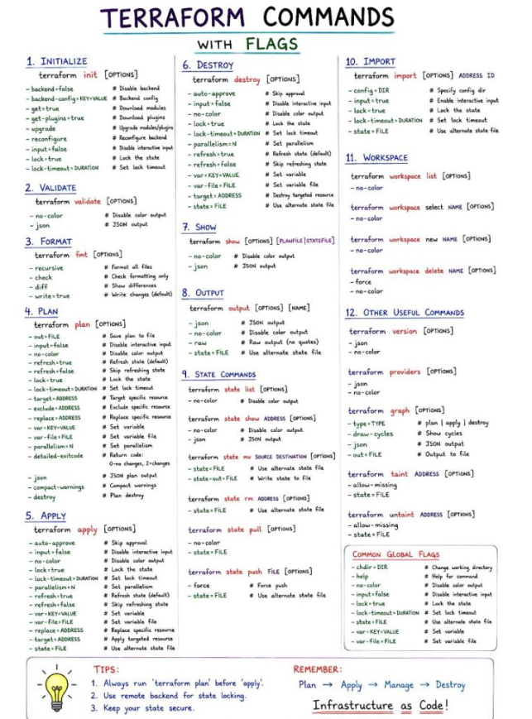

1. Terraform Commands – Terraform init, terraform plan, terraform apply
2. state file will be created on terraform apply
3. Load balancers – NLB, ALB, Classic and Gateway
4. Microsoft Cloud Adoption Framework (CAF) for Azure is a comprehensive set of documentation, guidance, best practices, and tools designed to help organizations create and implement business and technology strategies for the cloud.
1. Strategy ──► 2. Plan ──► 3. Ready ──► 4. Adopt ──► 5. Govern ──► 6. Manage
1. Strategy (The "Why")
- Purpose: Define the business justification, motivations, and expected outcomes for moving to Azure.
2. Plan (The "Who" and "How")
- Purpose: Align people, processes, and timelines to create a technical migration backlog.
3. Ready (The "Where")
- Purpose: Prepare the cloud environment to host workloads securely. This is where technical cloud architects spend most of their time.
4. Adopt (The Execution)
- Purpose: Implement the actual technical transition. This methodology splits into two parallel implementation paths:
5. Govern (The Guardrails)
- Purpose: Maintain environmental compliance, security, and cost control across the cloud estate as it scales.
6. Manage (The Operations)
- Purpose: Maintain stable daily operations, backup strategies, and disaster recovery processes for production workloads

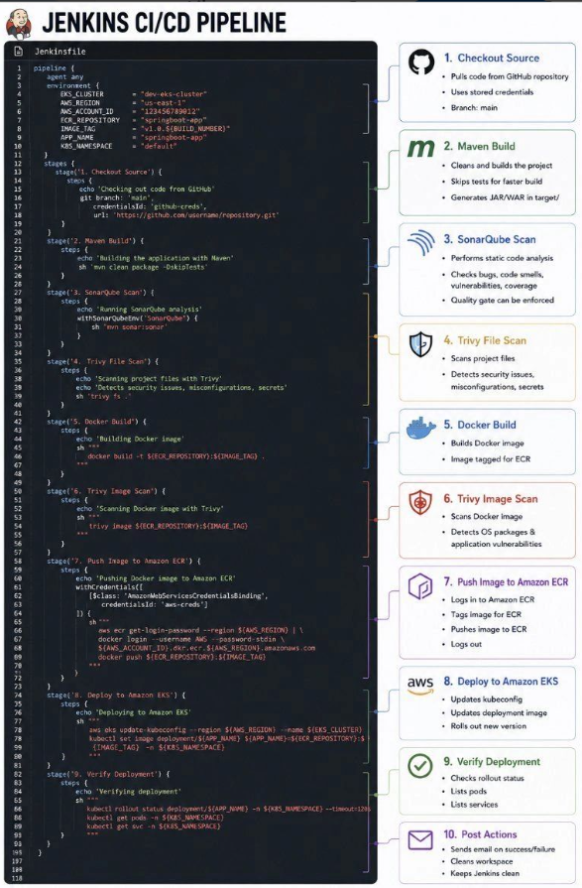
Q1. Can you introduce yourself and explain your professional experience?
Q2. Can you explain the end-to-end CI/CD pipeline in your current project?
Q3. What Jenkins strategy did you use in your project, and what type of Jenkins pipeline did you implement?
Q4. How did you secure sensitive data and secrets in your project?
Q5. What is a Canary Deployment, and when would you use it?
Q6. What is Blue-Green Deployment, and how does it differ from Canary Deployment?
Q7. Which deployment strategy would you recommend for a real-time production project, and why?
Q8. Could you explain AWS Lambda and its common use cases?
Q9. What is the difference between AWS Lambda and AWS Fargate?
Q10. What monitoring tools have you used in your current project, and how have you used them?
Q11. What is S3 Bucket Versioning, and why is it important?
Q12. How do you design and manage microservices in your project?
Q13. How have you used Karpenter to optimize Kubernetes cluster costs?
Q14. If a production deployment fails, how would you troubleshoot the issue and recover from it?

